**CENWP-OD-J 2/27/2023**

**MEMORANDUM FOR THE RECORD**

**SUBJECT: 23JDA03 MFR South Fish Turbine #3 out of service**

During an oil change of the gear box of South fish turbine #3, metal shavings were found in the filter. Upon draining 70 gallons of oil from the gearbox to inspect the gears and bearings, additional metal shavings and fragments were found on the bottom of the gearbox(fig1). Representatives from the Philadelphia gear company inspected the gear box on 22 February and determined the input shaft gear bearing to be the cause of the metal and recommend it be replaced before more significant damage occurs to other internal components.

John Day project will finish maintenance activities on South fish turbine #3 and return it to service as a reserve pump in the event South fish turbine pumps 1 or 2 fail during the passage season.

1. Future and Preventative Measures – Estimates of repairs will be provided by Philadelphia gear company. The type of repair is beyond JD projects capabilities.

**UPDATE: 3/6/2023**

Upon review of recommendations from the Philadelphia gear company and concurrence from JD project maintenance staff, South fish turbine #3 will be forced out of service until repairs can be made to the input shaft bearing in the gear box. It’s determined that the gearbox is too unsafe to operate in its current condition and operating it will cause more permanent damage to the internal gearing of the gearbox and could eventually catastrophically fail.

An inspection team from Philadelphia gear will be on site 11 March to scope out repair options to the gearbox. Once a quote is prepared and an option selected, JD project staff and NWP will prepare a UFR for emergency repair to return South fish turbine pump #3 ASAP.

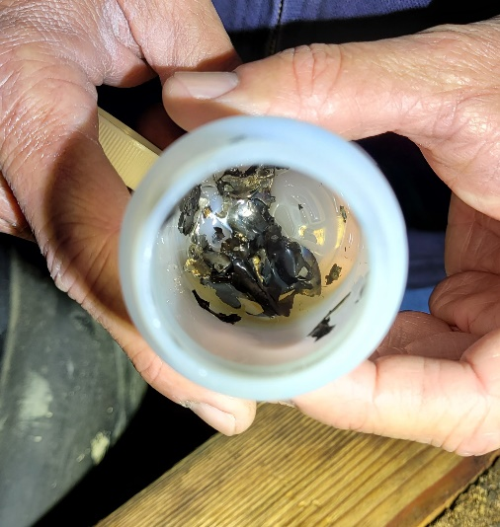

Fig 1: Metal fragments pulled from gearbox

Sincerely,

Project Fisheries